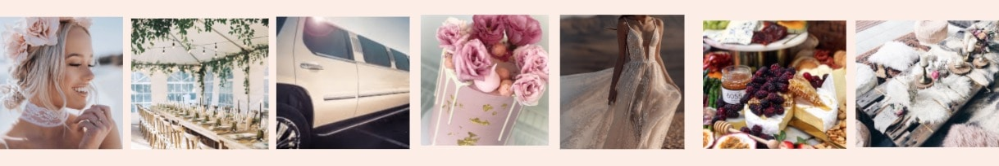

The Real Event Hosts of WA Feature

Please copy and paste the questions below into an email, enter your responses to as many questions as possible, upload images and send via email to theeventseditteam@gmail.com
OR enter your responses directly into this Word document, attach the document.

What was your event? Eg Kylie's Hens, Nate's 1st Birthday, Simone and Joel's Engagement etc

Did you have a theme?

Tell us all about your event the styling, decorations, food, entertainment, music, games etc.

Tell us about your event planning experience.

What are your favourite memories from your event?

What are your tips for anyone planning the type of event you held?

Would you have done anything differently?

Date of your event?

Location of Event and why did you choose this location?

Photography by?

Anything else you can tell us?

